DESIZN CIRCLE – UCEED 2015

GOVT. LOGOS

[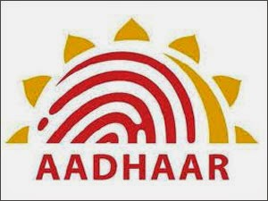](http://3.bp.blogspot.com/-Ai08kWkcJus/U6KrKGIFQDI/AAAAAAAAH98/SopsUVGNmkg/s1600/Aadhar+logo.jpg)

**Aadhar Card**

[](http://4.bp.blogspot.com/-gbgD4pZdqyM/U6KrbDNFHJI/AAAAAAAAH-E/o5-bLVoNWlU/s1600/Airports_Authority_of_India_logo.png)

**Airports Authority of India**

[](http://3.bp.blogspot.com/-9sq8Gf5RjJk/U6Krj0ZpKHI/AAAAAAAAH-M/GRuGAwku0rw/s1600/advocate.jpeg)

**Advocate**

[](http://1.bp.blogspot.com/-qU5-IQ9quHc/U6KrxMaq01I/AAAAAAAAH-U/DlADMXlFgmg/s1600/Air_India_Logo.png)

**Air India**

[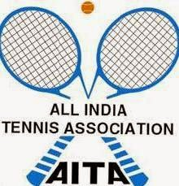](http://1.bp.blogspot.com/-5ewNW-gCEFM/U6Kr5RD2MLI/AAAAAAAAH-c/9IxIyHCx7BE/s1600/aita_logo1.jpg)

**All India Tennis association**

[](http://1.bp.blogspot.com/-Ka2oCGPlhDc/U6KsCf7geKI/AAAAAAAAH-k/dUmD7kg7-go/s1600/All+India+football+federation.png)

**All India Football federation**

[](http://2.bp.blogspot.com/-pKmxJUT5OHw/U6KsORrxZvI/AAAAAAAAH-s/NxAkU6vzNSg/s1600/All+India+IT+association.jpg)

**All India IT association**

[](http://1.bp.blogspot.com/-XnbYnrA_7Xk/U6KsW38DjKI/AAAAAAAAH-0/vr7LOxsB_Ic/s1600/All+iNDIA+TRADE+PROMOTION+CONGRESS.jpg)

**All India Trade Promotion Congress**

[](http://1.bp.blogspot.com/-GmuQ5Y7wc4c/U6KsenbiiPI/AAAAAAAAH-8/grLzIE8K2R8/s1600/Archeology+survey+of+India.jpg)

**Archaeology Survey of India**

[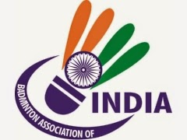](http://4.bp.blogspot.com/-_A7uXbo-l1k/U6KssOqXnHI/AAAAAAAAH_E/oV8TCbKx-54/s1600/Badminton+association+of+India.jpg)

**Badminton Association of India**

[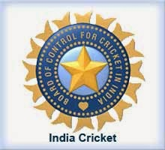](http://1.bp.blogspot.com/-CdXmrCQVcPw/U6Ks0M06R1I/AAAAAAAAH_M/GujsGheAOZY/s1600/Board+of+control+for+India+logo.jpg)

**Board of Control for Cricket in India**

[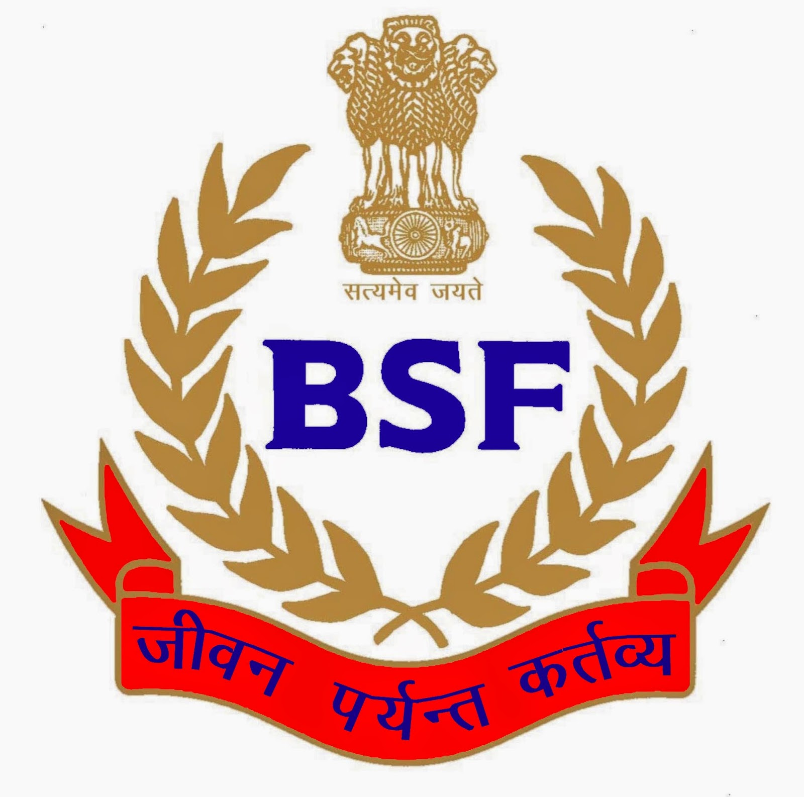](http://4.bp.blogspot.com/-7t2sz1Bt8fM/U6Ks8xhZR6I/AAAAAAAAH_U/wVaRj0WBqJ0/s1600/BSF-Logo.jpg)

**Border Security Force**

[](http://4.bp.blogspot.com/-xoL40fn1UUQ/U6KtGLhEvEI/AAAAAAAAH_c/s92xKAXIZeo/s1600/Council_of_Scientific_and_Industrial_Research_logo.png)

**Council of Scientific and Industrial Research**

[](http://2.bp.blogspot.com/-0XQ_YwmzOQk/U6KtOEaVGyI/AAAAAAAAH_k/oS0gtDk9Xg4/s1600/Delhi_Metro_logo.png)

**Delhi Metro**

[](http://2.bp.blogspot.com/-tyY2tKE0wrs/U6KtXFejrhI/AAAAAAAAH_s/qAM_mMkOF_Q/s1600/Dental_Council_of_India_logo.png)

**Dental Council of India**

[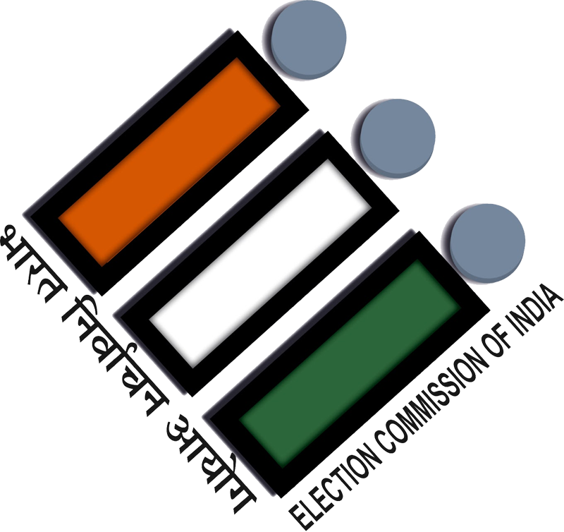](http://4.bp.blogspot.com/-Frj5S33kRqk/VHigt-qXR-I/AAAAAAAAJTc/WAC72An4Z4o/s1600/Election_Commission_of_India_Logo.png)

**Election Commission of India**

[](http://2.bp.blogspot.com/-PFEqlRsxVzU/U6KtrTh9e2I/AAAAAAAAH_8/6ENIdpFiHxM/s1600/Engineering+association+of+India.jpg)

**Engineering association of India**

[](http://4.bp.blogspot.com/-xbnEBJIq_Wg/U6KtzmGygPI/AAAAAAAAIAE/8t2-UXwzZek/s1600/federation+of+Indian+chambers+of+commerce+and+Industry+(FICCI).png)

**Federation of Indian chambers of commerce and Industry (FICCI)**

[](http://2.bp.blogspot.com/-RxcOkdNVpEY/U6Kt6Y1ER5I/AAAAAAAAIAM/4o2TAn7TI-E/s1600/Food+corporation+India.jpg)

**Food Corporation India**

[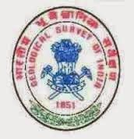](http://1.bp.blogspot.com/-gvzqlnyqLDw/U6KuGPcIeBI/AAAAAAAAIAU/sG1Ho3nZGo4/s1600/geological+survey+of+India.jpg)

**Geological Survey f India**

[](http://2.bp.blogspot.com/-uMiVSIft6sY/U6KuNpVPvvI/AAAAAAAAIAc/yLmnJcEDc3A/s1600/Hockey_india_Logonewone.jpg)

**Hockey India**

[](http://4.bp.blogspot.com/-CHpBcnNGoOE/U6KuWP0soXI/AAAAAAAAIAk/SUw2Y6x8-q8/s1600/icwai+logo.jpg)

**The Institute of Cost Accountants of India**

[](http://1.bp.blogspot.com/-HpqENSsLKBo/U6KulIgAjBI/AAAAAAAAIAs/EqNLSG49wPg/s1600/IEA.jpg)

**Indian Engineers Association**

[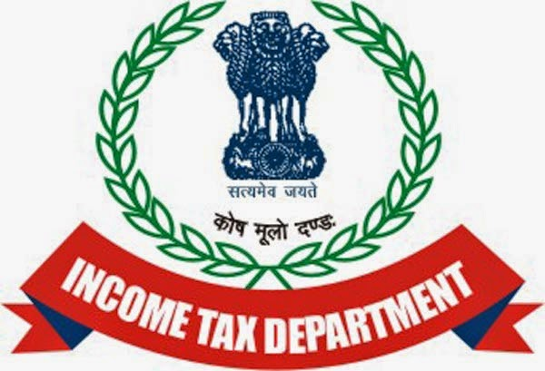](http://2.bp.blogspot.com/-GH66Sn2ph8w/U6Kur1C2wCI/AAAAAAAAIA0/jBOa9L0AEMw/s1600/Income+Tax+department.jpg)

**Income Tax department**

[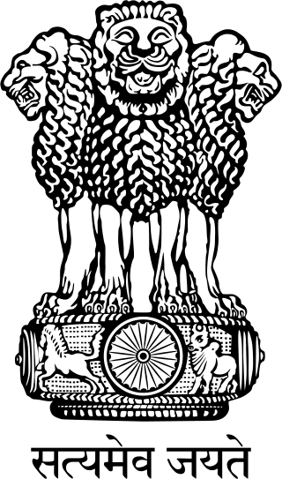](http://3.bp.blogspot.com/-npkIuIACwng/U6KuzQaQ99I/AAAAAAAAIA8/czx2e9Z2vPA/s1600/India+Emblem.png)

**India Emblem**

[](http://2.bp.blogspot.com/-lcwmkjSsjiQ/U6Ku7S3EFKI/AAAAAAAAIBE/KLkTeoAmVo4/s1600/India+Trade+promotion+organization.png)

**India Trade Promotion Organization**

[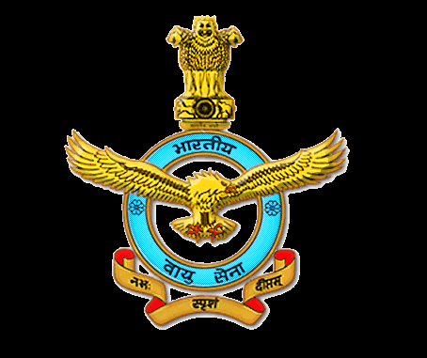](http://3.bp.blogspot.com/-i-0b5xKf9mM/U6KvFS3WoQI/AAAAAAAAIBM/3HNYm1M2niI/s1600/Indian+airforce.png)

**Indian Air force**

[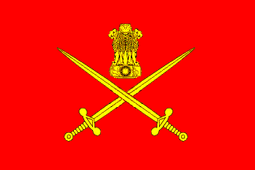](http://4.bp.blogspot.com/-tiP0FmfQUMg/U6KvQIVEdoI/AAAAAAAAIBU/0p0c1tM9bAA/s1600/Indian+army.gif)

**Indian Army**

[](http://3.bp.blogspot.com/-TP3CXW4BHIQ/U6KvdGtemyI/AAAAAAAAIBc/5b20o2uhvbw/s1600/Indian+arta+and+crafts+association.jpg)

**Indian Arts and Crafts association**

[](http://1.bp.blogspot.com/-Z0jqORszBlw/U6KvkV5-LNI/AAAAAAAAIBk/xK4fpXCPkSs/s1600/Indian+association+congress.jpg)

**Indian Association Congress**

[](http://3.bp.blogspot.com/-2u7eGfP4vVY/U6Kvvg8houI/AAAAAAAAIBs/348SxTTkr5s/s1600/Indian+audits+and+accounts+departments.png)

**Indian Audits and Accounts departments**

[](http://4.bp.blogspot.com/-ffhcXrSu37E/U6Kv6nRfejI/AAAAAAAAIB0/OaOKOObwLSw/s1600/Indian+bank+association.jpg)

**Indian Bank association**

[](http://3.bp.blogspot.com/-JD3w9sippeI/U6KwFxEGclI/AAAAAAAAIB8/03VH3XHKLaw/s1600/Indian+blind+sports+association.JPG)

**Indian Blind sports association**

[](http://3.bp.blogspot.com/-5IBEzmnOzHE/U6KwObP9ebI/AAAAAAAAICE/DS3EJK_lMm0/s1600/Indian+christian+mission.gif)

**Indian Christian Mission**

[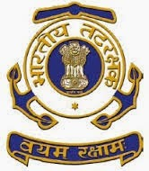](http://4.bp.blogspot.com/-oXhAYWDhgX0/U6KwWJTVebI/AAAAAAAAICM/kD5YYTSlbtk/s1600/Indian+coast+guard.jpg)

**Indian Coast guard**

[](http://1.bp.blogspot.com/-Adyoxpn8vDA/U6Kwi_vvGJI/AAAAAAAAICU/japHvMTQm48/s1600/Indian+council+of+Agricultural+Research+(ICAR).jpg)

**Indian Council of Agricultural Research (ICAR)**

[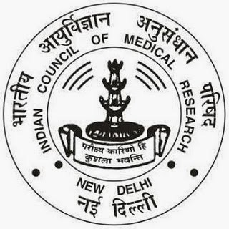](http://2.bp.blogspot.com/-GQCScPx89_0/U6KwrQhvD9I/AAAAAAAAICc/gDThabODLtU/s1600/Indian+Council+of+Medical+Research_ICMR_Logo.jpg)

**Indian Council of Medical Research (ICMR)**

[](http://3.bp.blogspot.com/-FApL-FV0PJY/U6Kw2FI0tnI/AAAAAAAAICk/zIWwhHz5BNk/s1600/Indian+franchise+association.gif)

**Indian Franchise Association**

[](http://3.bp.blogspot.com/-59t3kjXTtEE/U6Kw9XtT1eI/AAAAAAAAICs/Aj8ac2ldsj8/s1600/Indian+health+service.jpg)

**Indian Health Service**

[](http://4.bp.blogspot.com/-t490sAZeeTg/U6KxHBVl8ZI/AAAAAAAAIC0/w6-Cq8Nte7Q/s1600/Indian+Institute+of+Architects.jpg)

**Indian Institute of Architects**

[](http://3.bp.blogspot.com/-hbrgNC337f4/U6K9rb4_jnI/AAAAAAAAIDE/C4nuXWGMtJ0/s1600/Indian+Institute+of+Foreign+trade.jpg)

**Indian Institute of Foreign Trade**

[](http://4.bp.blogspot.com/-I3S1llcmAy8/U6K9yh8M_hI/AAAAAAAAIDM/qAMDKbviMfA/s1600/Indian+Medical+Association.jpg)

**Indian Medical Association**

[](http://2.bp.blogspot.com/-fbf2y2ooyfY/U6K96ZCyGBI/AAAAAAAAIDU/z91jdogYjiQ/s1600/Indian+Navy.gif)

**Indian Navy**

[](http://3.bp.blogspot.com/-1N7HK-skYts/U6K-Ylxv4FI/AAAAAAAAIDk/_wQGnSdXxNU/s1600/Indian+post.png)

**Indian Post**

[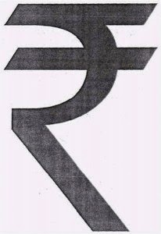](http://3.bp.blogspot.com/-TBcUFjrqAEU/U6LB6PZu4jI/AAAAAAAAIDw/6T_W0hp1YuQ/s1600/Indian+rupee.jpg)

**Indian Rupee**

[](http://2.bp.blogspot.com/-W9S4kq0FLhc/U6LCRb5t-7I/AAAAAAAAID4/SpI5zDEt7L0/s1600/Indian+tourism.jpg)

**Indian Tourism**

[](http://3.bp.blogspot.com/-HZ6rLCeruHk/U6LCYA5KIiI/AAAAAAAAIEA/fg1sH6vfYIg/s1600/Indian_airline+logo.png)

**Indian Airline**

[](http://1.bp.blogspot.com/-ooPCdRoRtec/U6LCevD_6DI/AAAAAAAAIEI/BgrELGRDH4M/s1600/Indian_Water_Works_Association_(IWWA).jpeg)

**Indian Water works association**

[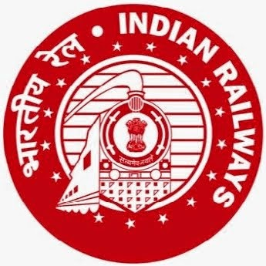](http://3.bp.blogspot.com/-DTSiQaCSUUQ/U6LCkBxYvxI/AAAAAAAAIEQ/9wUDMcKpP_U/s1600/Indian-Railway-Logo.jpg)

**Indian Railway**

[](http://2.bp.blogspot.com/-6Jnii1FTsGo/U6LCsfr6nYI/AAAAAAAAIEY/cJbLOoQnaG8/s1600/Institute_of_Chartered_Accountants_of_India_logo.jpg)

**Institute of Chartered Accountants**

[](http://1.bp.blogspot.com/-ZUd5973XDGM/U6LCzCbc3ZI/AAAAAAAAIEg/2NAbH5uL0sk/s1600/International+association+for+public+transport.gif)

**International association for public transport**

[](http://4.bp.blogspot.com/-cLMYQP2AlwE/U6LC5wBmwFI/AAAAAAAAIEo/ogGgLhvZM5o/s1600/International+cricket+council.png)

**International Cricket Council**

[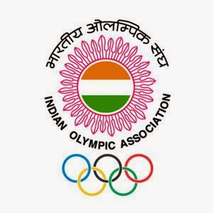](http://2.bp.blogspot.com/-HRwzkI5obhg/U6LDcIoPVJI/AAAAAAAAIEw/tpslT6UXlZI/s1600/IOA-logo.jpg)

**Indian Olympic Association**

[](http://1.bp.blogspot.com/-YylSfrpH17w/U6LDnx3YsaI/AAAAAAAAIE4/f5o53cZRBtQ/s1600/IRCTC+India.jpg)

**IRCTC**

[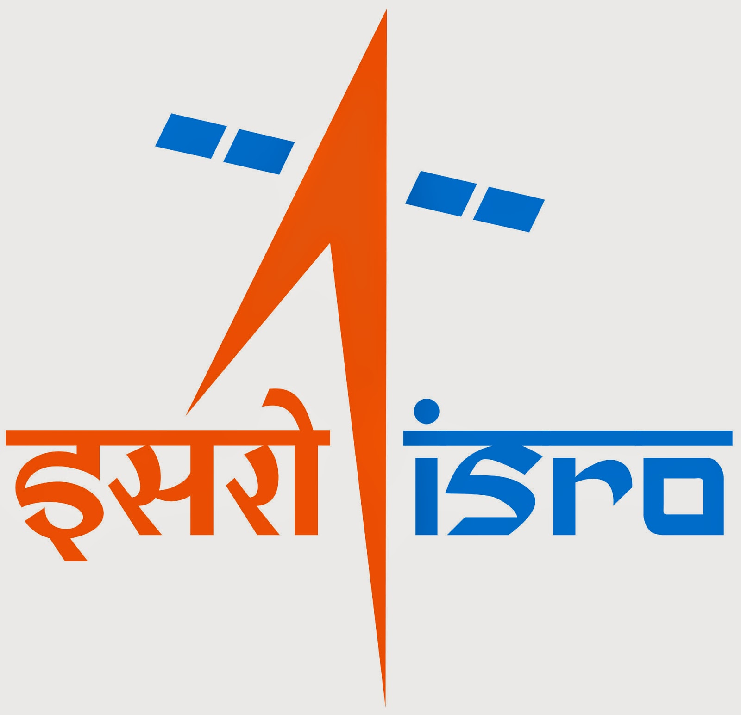](http://1.bp.blogspot.com/-cSPJtsqVDc0/U6LDxFGNzSI/AAAAAAAAIFA/ChwETQ66R20/s1600/ISRO.jpeg)

**Indian Space Research Corporation**

[](http://2.bp.blogspot.com/-u24R49aqCeg/U6LD4l3v2mI/AAAAAAAAIFI/ffu8sTjpY3Q/s1600/LIC+India.jpg)

**LIC India**

[](http://3.bp.blogspot.com/-uDkejoraLJY/U6LD_Hj9zmI/AAAAAAAAIFQ/FuHxXzKN2aU/s1600/NABARD.jpg)

**National Bank for Agriculture and Rural Development**

[](http://1.bp.blogspot.com/-MoPEUG92cMs/U6LEFrz7oqI/AAAAAAAAIFY/aQveueQIfWM/s1600/National+Institute+of+Educational+Research+and+Training.png)

**National Institute of Educational Research & Training**

[](http://2.bp.blogspot.com/-zoJMe6EvSTA/U6LELq7IxII/AAAAAAAAIFg/WsPo4owscJ4/s1600/National+Literacy+mission.jpg)

**National Literacy Mission**

[](http://2.bp.blogspot.com/-P6-tcn6__go/U6LES1wo06I/AAAAAAAAIFo/OnzPG9AVFoc/s1600/National+programe+on+earthquake+engg+educ.gif)

**National program on earthquake Engg Education**

[](http://1.bp.blogspot.com/-hoFJycuRdHw/U6LEYbPEgMI/AAAAAAAAIFw/5TiD-Mn-_gs/s1600/National+Textile+corporation.jpg)

**National Textile Corporation**

[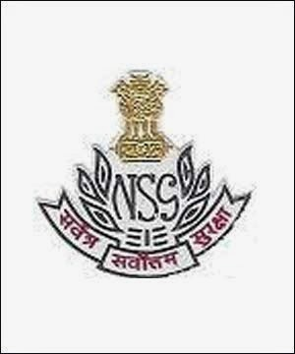](http://4.bp.blogspot.com/-33HbD_i7mlg/U6LEf3OvrFI/AAAAAAAAIF4/9KI_6qnXSog/s1600/National_Security_Guards.jpg)

**National Security Guards**

[](http://4.bp.blogspot.com/-IZXerxC8_2g/U6LEl4AjHVI/AAAAAAAAIGA/oJZEh20R7Mk/s1600/National_Tiger_Conservation_Authority_logo.png)

**National Tiger Conservation Authority**

[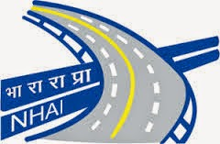](http://3.bp.blogspot.com/-QajWRqKsREQ/U6LEsYPSYqI/AAAAAAAAIGI/nf5V7C5EaKI/s1600/NHAI.jpg)

**National Highway Authority of India**

[](http://4.bp.blogspot.com/-nj-lGPwMuVQ/U6LEyNe-EAI/AAAAAAAAIGQ/JPVIkwynBDU/s1600/NID.jpg)

**National Institute of Design**

[](http://2.bp.blogspot.com/-G5LiSKE9OX8/U6LE67BHegI/AAAAAAAAIGY/Xwh9FvVZBzw/s1600/NIFT.jpg)

**National Institute of Fashion Technology**

[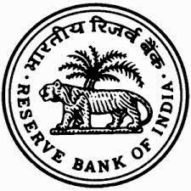](http://2.bp.blogspot.com/-SLs6RuRZFpo/U6LFCbpXdMI/AAAAAAAAIGg/0u56k6pE0Lc/s1600/Reserve+bank+of+India.jpg)

**Reserve Bank of India**

[](http://4.bp.blogspot.com/-gtzmj0o6f3s/U6LFIh6HWjI/AAAAAAAAIGo/Mk5atC9fQVo/s1600/Shipping+Corporation+of+India+Ltd.jpg)

**Shipping Corporation of India LTD**

[](http://1.bp.blogspot.com/-kB5rGUHzpnc/U6LFQPk2DKI/AAAAAAAAIGw/3EBp38ZTkcc/s1600/speedpost_logo.jpg)

**EMS speed post**

[](http://3.bp.blogspot.com/-ZSnm31eLsfs/U6LFWNIXRgI/AAAAAAAAIG4/5bnr4Y47OrM/s1600/state+farms+corporation+of+India+limited+logo.gif)

**State farms corporation of India LTD**

[](http://3.bp.blogspot.com/-9okbbhQp8-c/U6LFbYEgxhI/AAAAAAAAIHA/-QAf-4jc9Ao/s1600/The-Times-of-India-Logo-300x158.jpg)

**The Times of India**

[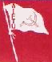](http://2.bp.blogspot.com/-gKC12WjCvFE/U6LFipzMUYI/AAAAAAAAIHI/CXwHtrjQeUs/s1600/Trade+Union+federation+of+India.png)

**Trade Union Federation of India**

[](http://4.bp.blogspot.com/-_wvoVSRqHhI/U6LFopwQdEI/AAAAAAAAIHQ/Lrwrb3c98b8/s1600/UGC_India_Logo.png)

**University Grants commission**

[](http://2.bp.blogspot.com/-R_rn6bzmlxk/U6LGFCqEcJI/AAAAAAAAIHY/XP3PtzQCk-w/s1600/UNESCO+Logo.jpg)

**United Nations Educational, Scientific and Cultural Organisation - UNESCO**

[](http://3.bp.blogspot.com/-zbreUrbhrsw/U6LGN8xlTwI/AAAAAAAAIHg/SRJfJ9_6VLE/s1600/united_india+Insurance.jpg)

**United India Insurance**

[](http://2.bp.blogspot.com/--BOeH44Bz_4/U6LGXqwZH2I/AAAAAAAAIHo/FtZZ6fw44kg/s1600/WHO.jpg)

**World Health Organization (WHO)**

[](http://3.bp.blogspot.com/-5RsNfeyWT_Y/U6LGhFl_yXI/AAAAAAAAIHw/dgrUqSNuXsY/s1600/World-Trade-Organisation-WTO-logo.gif)

**World Trade Organization (WTO)**